# Lab 04 Template - Ethan Roepke

[Don’t forget to follow these lab report instructions.](https://docs.google.com/document/d/17YVskN9GQxI6Erjl8pq7goWKIcbaZ7PeJeYBoVwNsKg/edit?usp=sharing)

1. **Screenshot of pfSense pinging gateway**

(10 points)

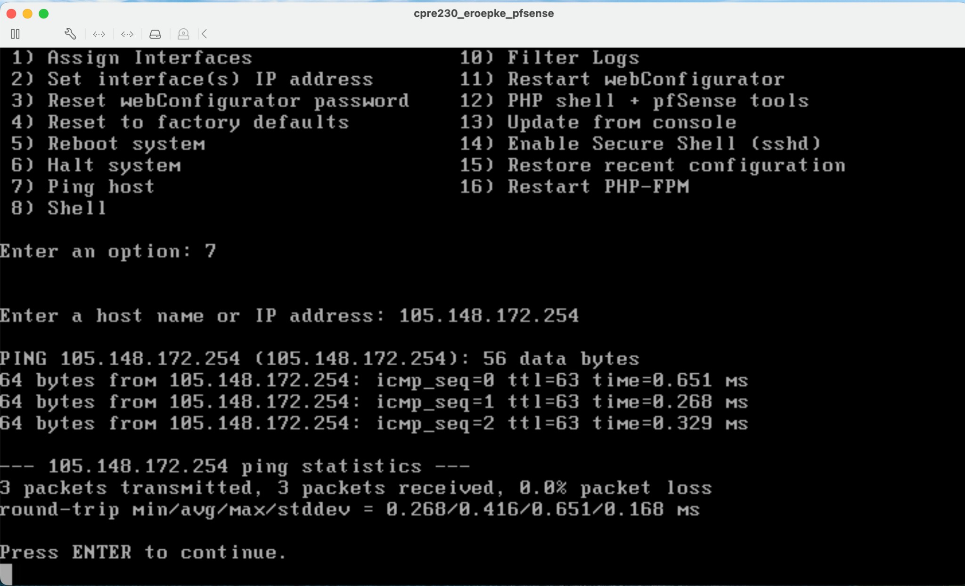

1. **Discussion of pros/cons of port forwarding only vs virtual IPs AND port forwarding**

(10 points)

The pros of port forwarding only is you may open access to certain servers. To run a website port forwarding is required so it is not blocked from firewall. Significant in increase speed is a big benefit and lastly you can start a VPN server.

The cons of port forwarding is creating holes in your firewall that outsiders can access to your network. Port forwarding can be complex to people if unfamiliar.

The pros of virtual IPs and port forwarding is the security, given applications to prevent from Trojans to hackers. This is a private network so won't be connected to external networks. Losses of internet connectivity will not affect the performance of the private network.

The cons of virtual IPs and port forwarding is maintenance cost and being a private network doesn’t allow for networks IP addresses to go onto public networks to communicate to other computers.

1. **Screenshot of successful ssh connection from your ns1 to your desktop**

(20 points)

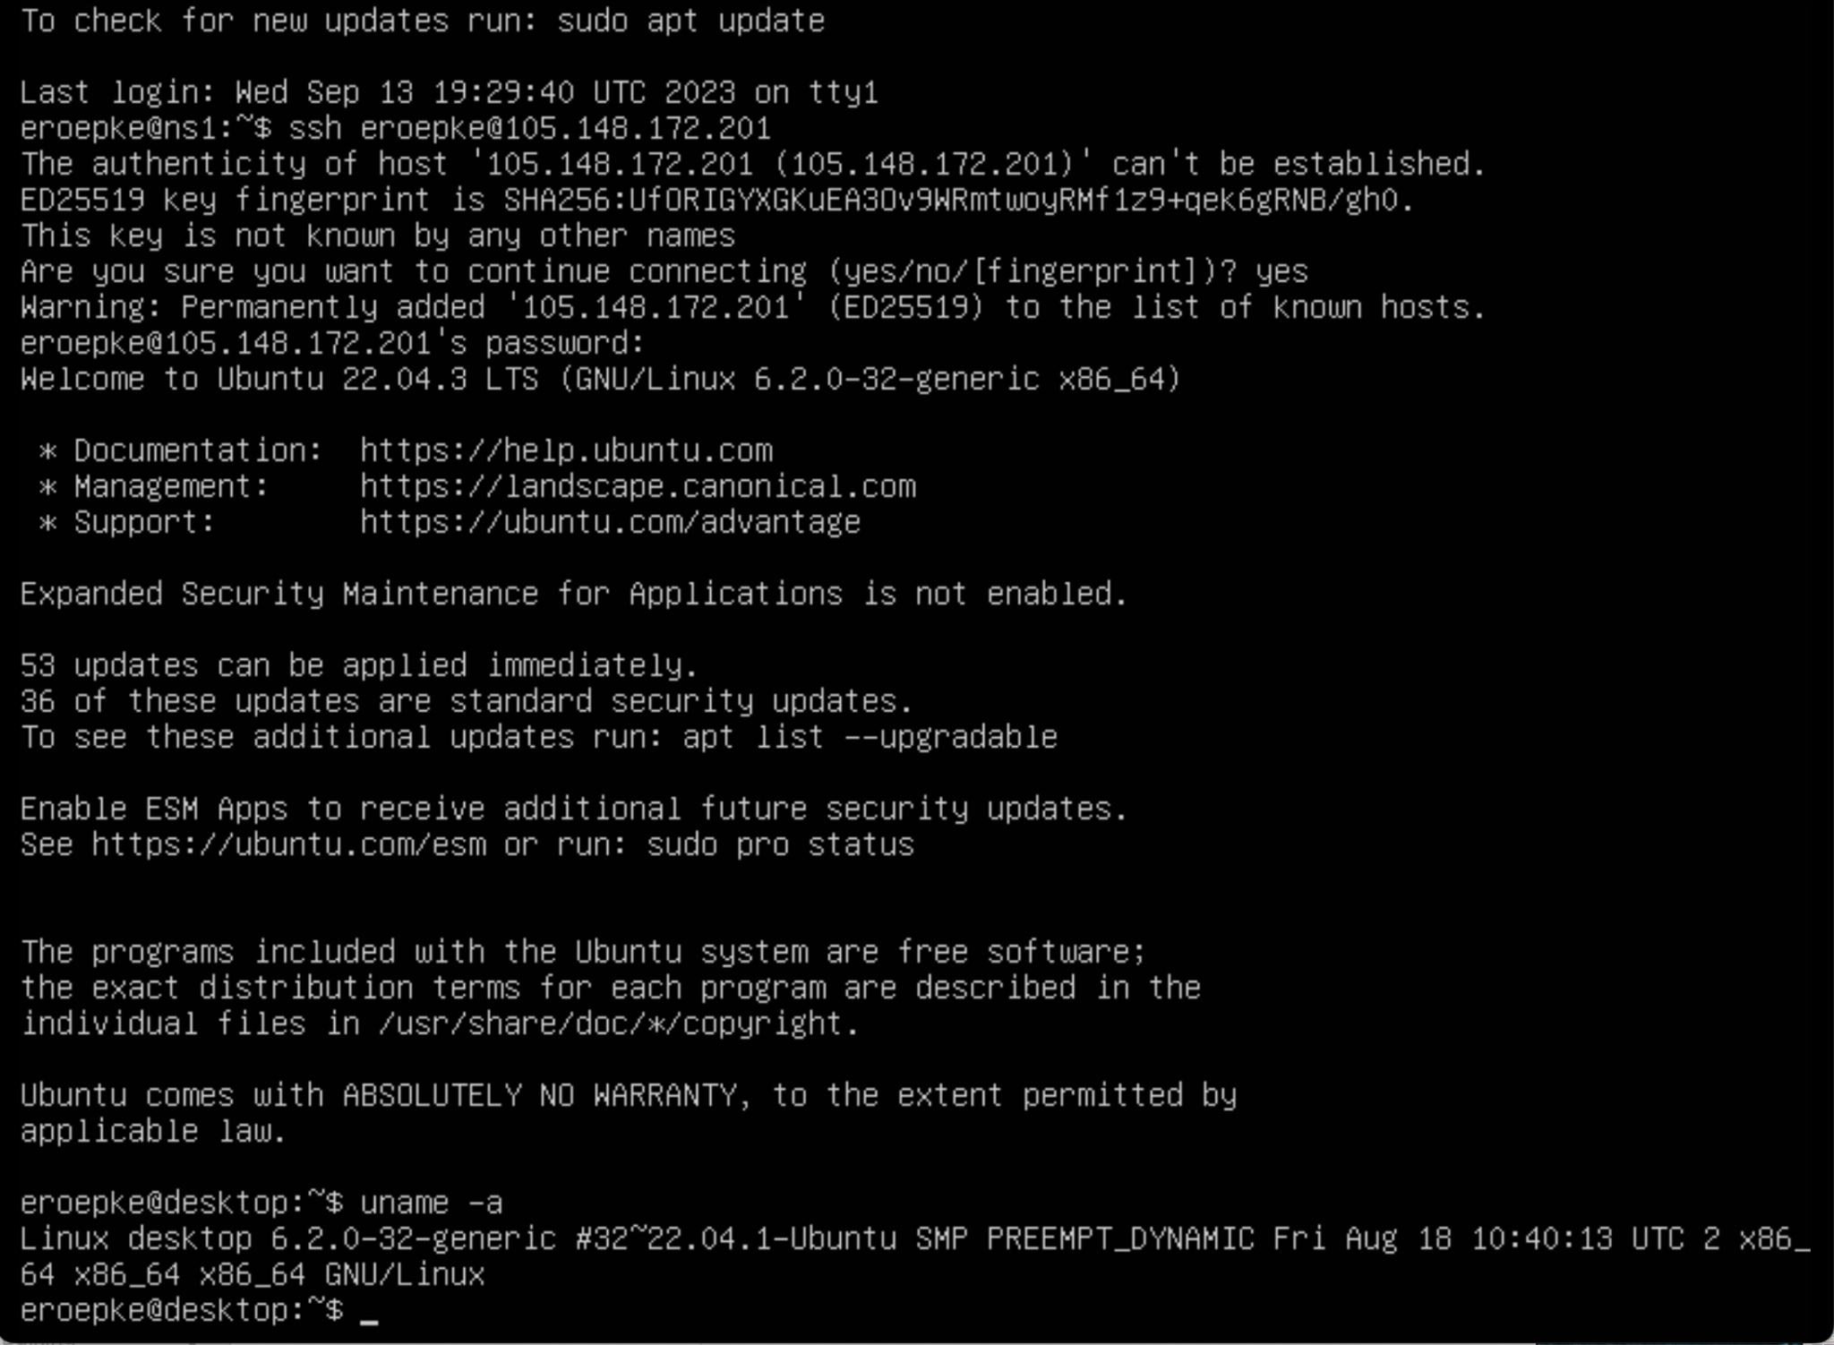

1. **Screenshots (2) of Virtual IP & NAT Forwarding config pages**

(20 points)

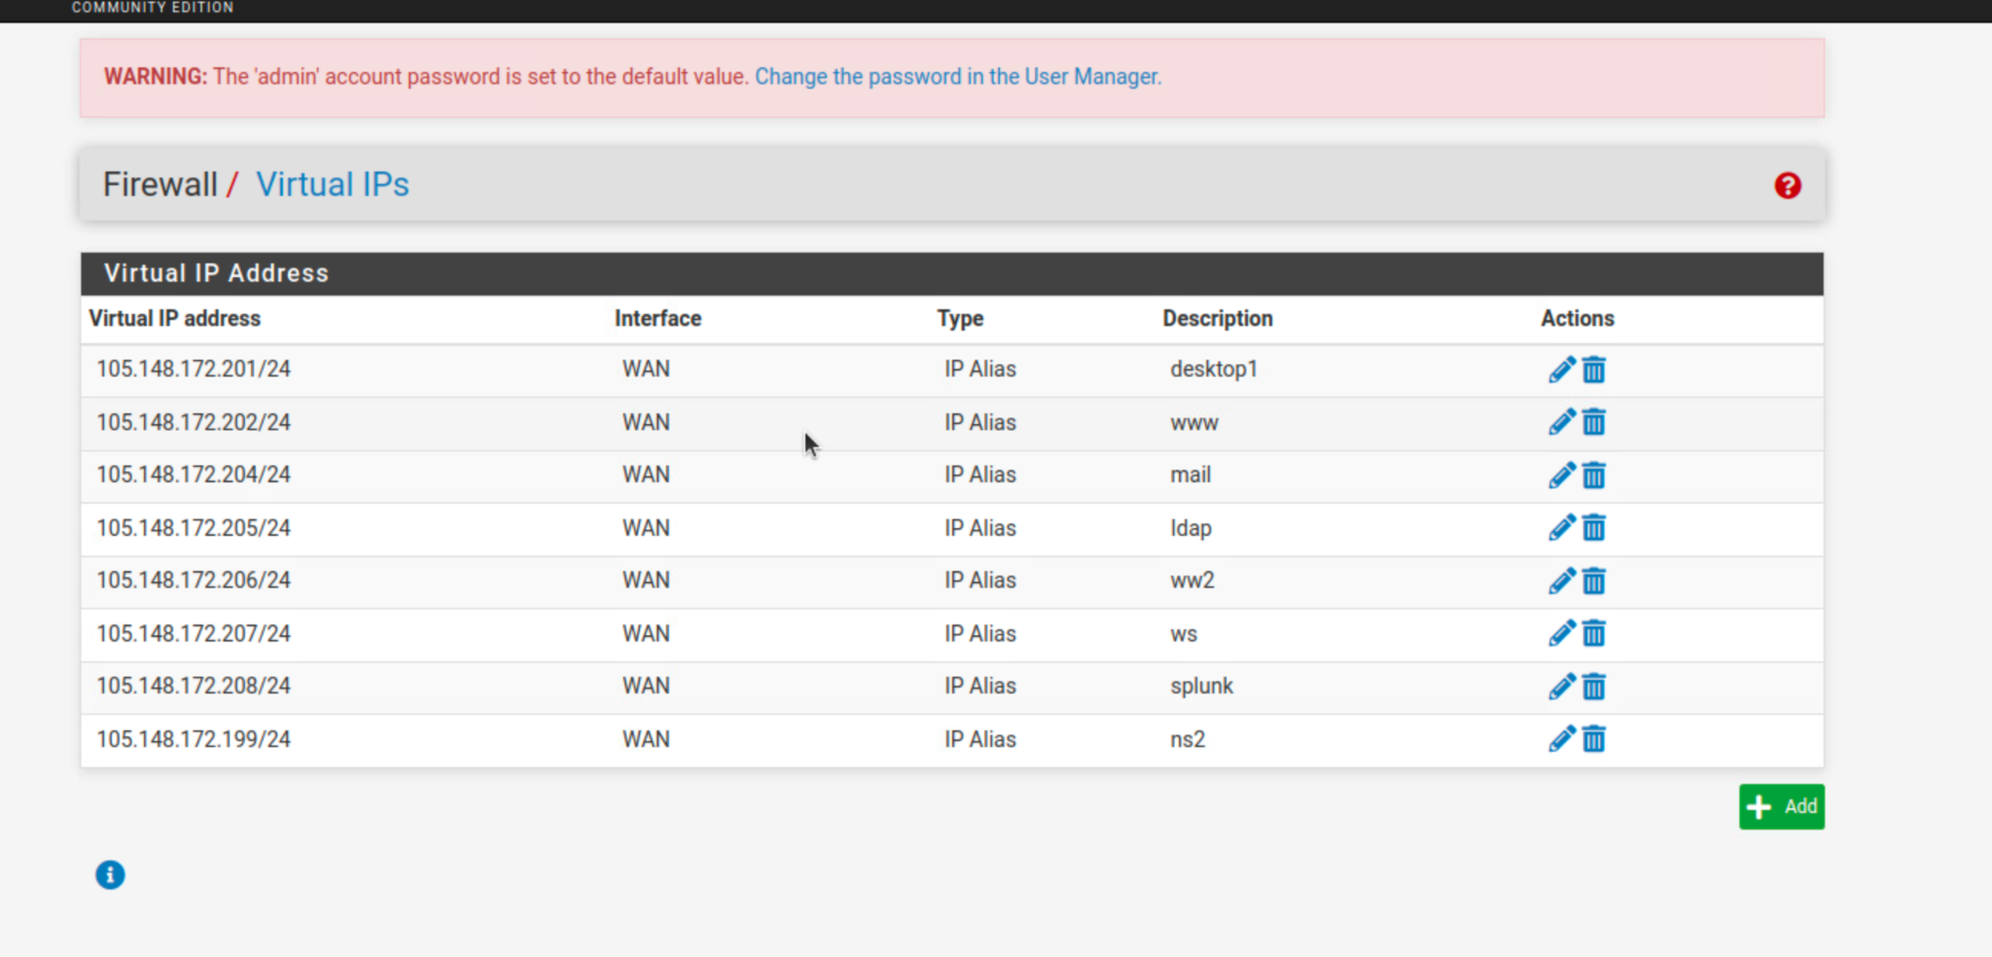

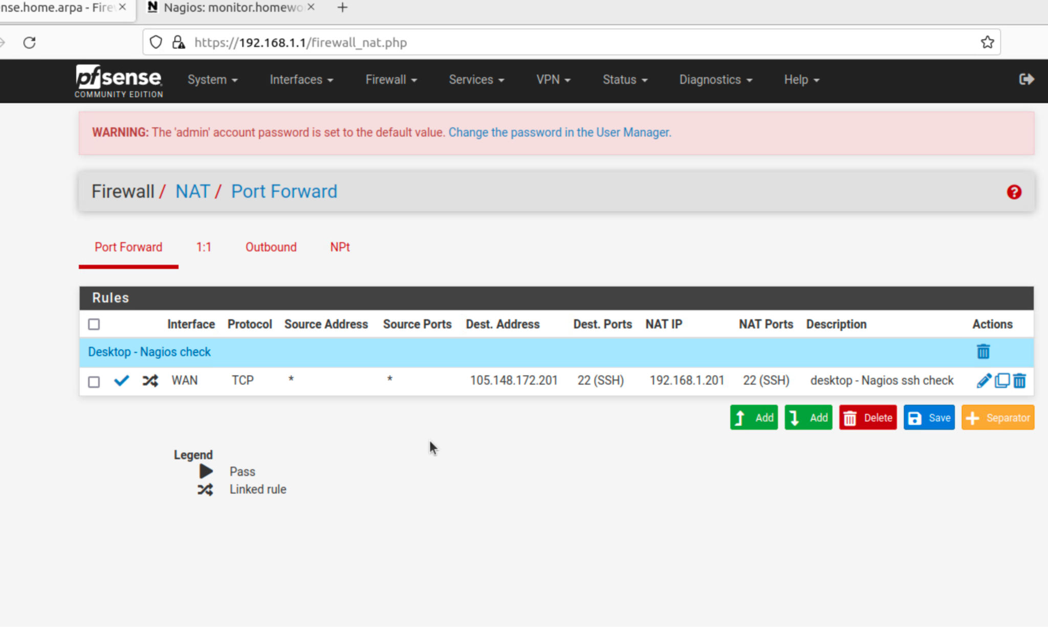

1. **Screenshot of successful Nagios check of ssh to desktop**

(20 points)

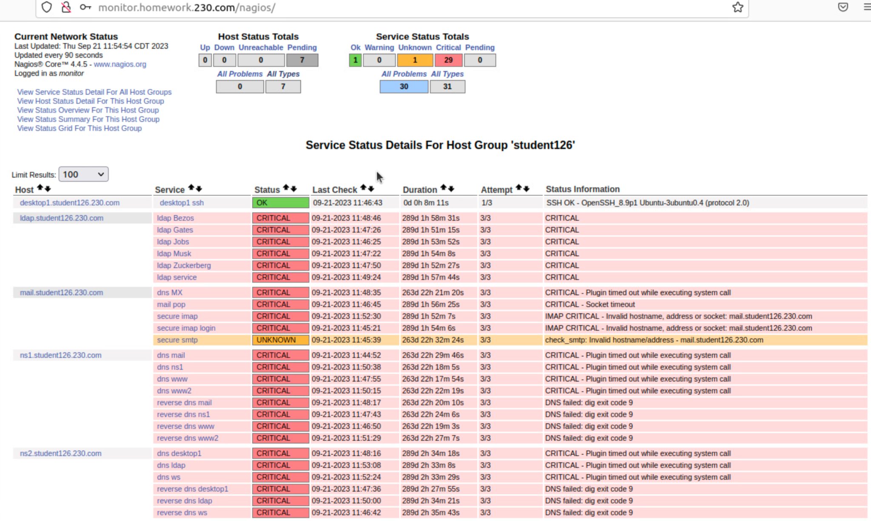

1. **StudentXX.230.com diagram with only machines and services currently running**

(20 points)

Portforwarding:

105.148.172.0/24

Default Gateway

105.148.172.254

105.148.172.206:22(ssh)



**ns1**

105.148.172.200

53/tcp – dns

53/udp - dns

105.148.172.0/24

pfSense

105.148.172.100

105.148.172.1



**Desktop1**

105.148.172.201